Intrusion Detection System (IDS) using Mininet and Scapy

1. Aim
To design and implement a simple IDS to monitor network traffic and detect abnormal activities in a simulated network.

2. Tools & Technologies
Kali Linux, Mininet, Ryu Controller, Python, Scapy, VMware

3. Implementation

Step 1: Install Required Packages
sudo apt update
sudo apt install docker.io -y
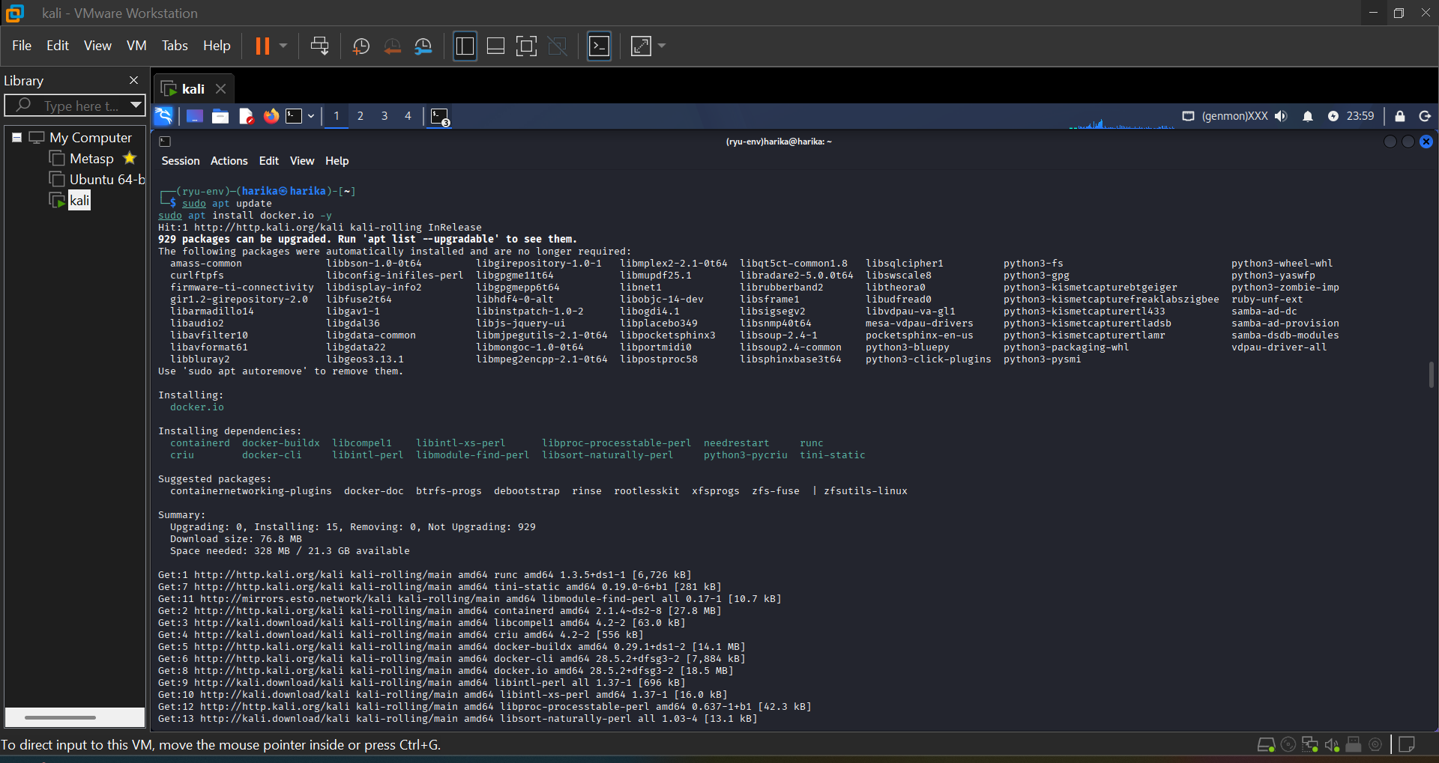

Step 2: Run Ryu Controller
sudo docker run -it --rm --network host osrg/ryu ryu-manager --ofp-tcp-listen-port 6633 ryu.app.simple_switch_13
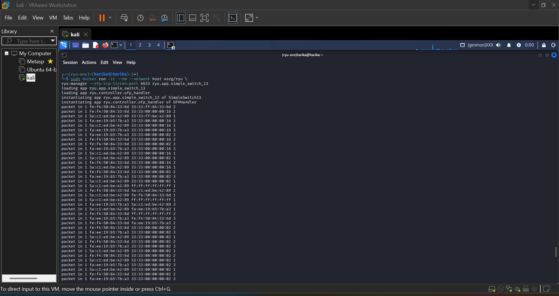

Step 3: Start Mininet Topology
sudo mn --topo single,3 --controller=remote,ip=127.0.0.1,port=6633 --switch ovsk,protocols=OpenFlow13
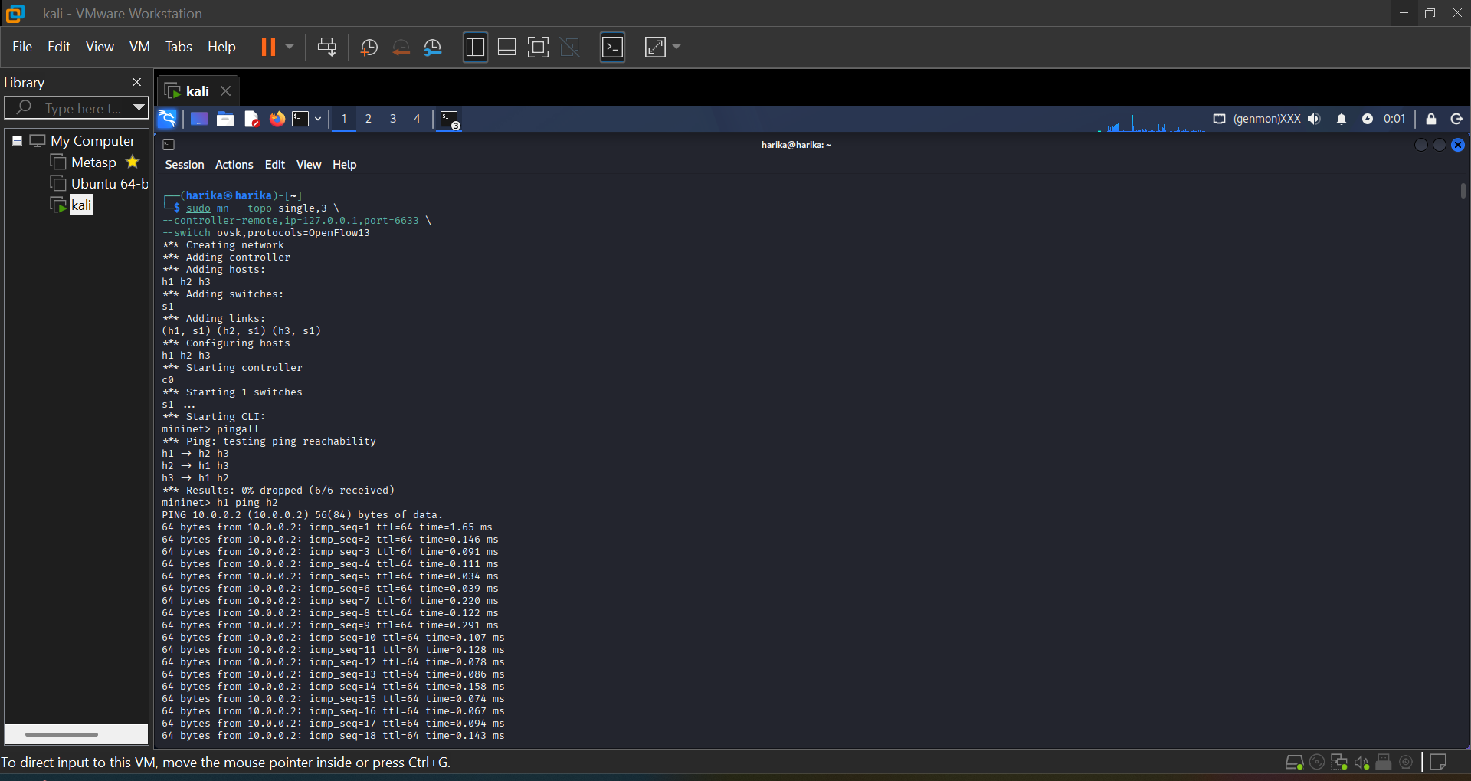

Step 4: Test Connectivity
pingall
h1 ping h2
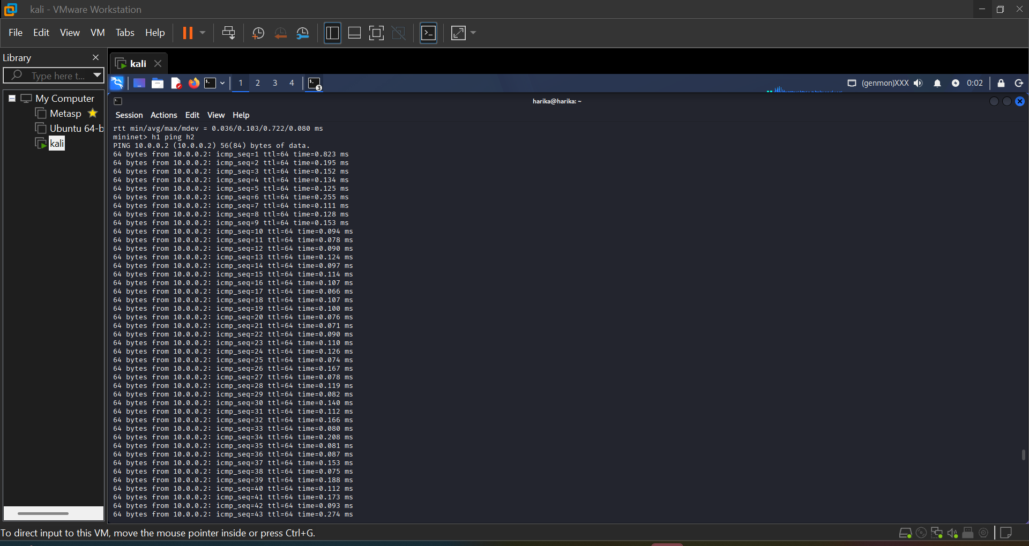

Step 5: IDS Python Code (monitor.py)
Python script used to monitor packets and detect attacks.
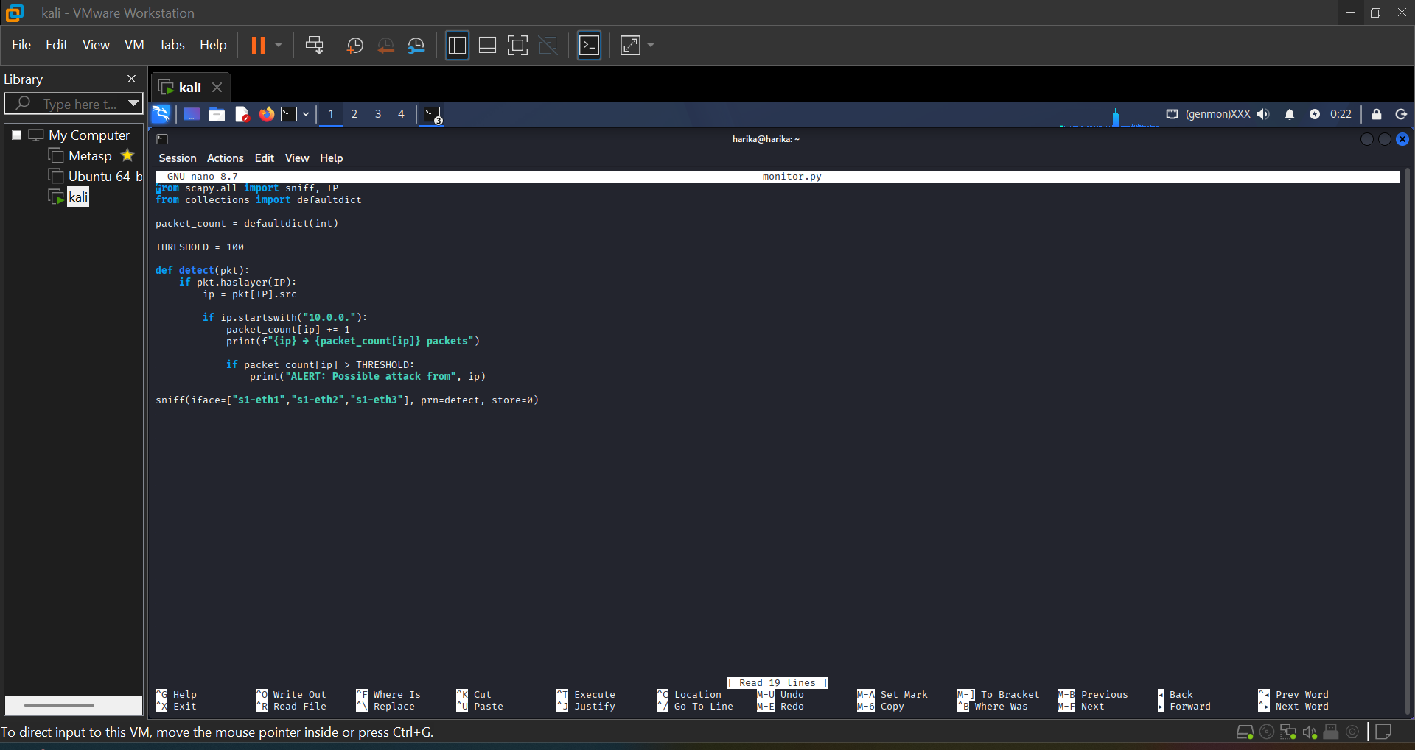

Step 6: Run IDS Script
sudo python3 monitor.py
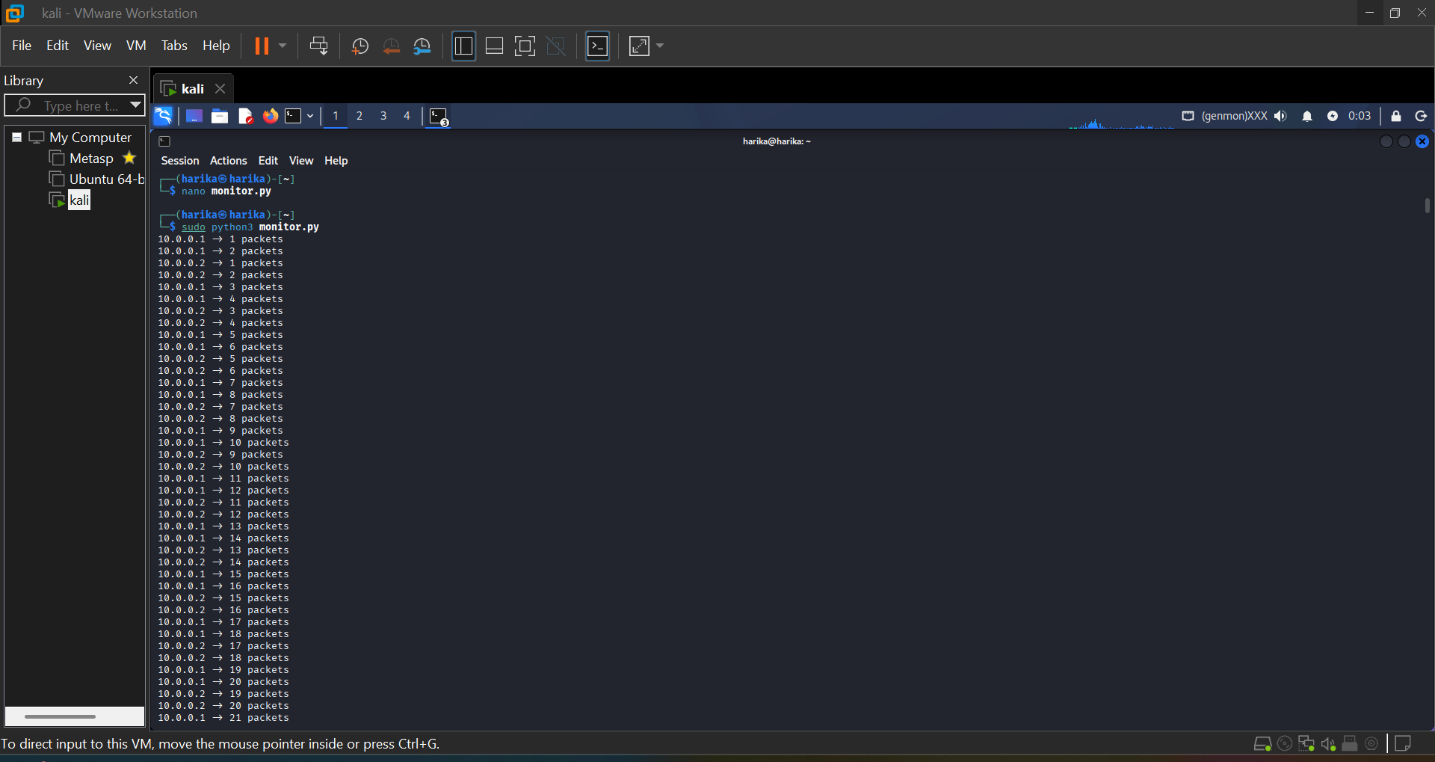

Step 7: Packet Monitoring
Monitoring packets and counting per IP
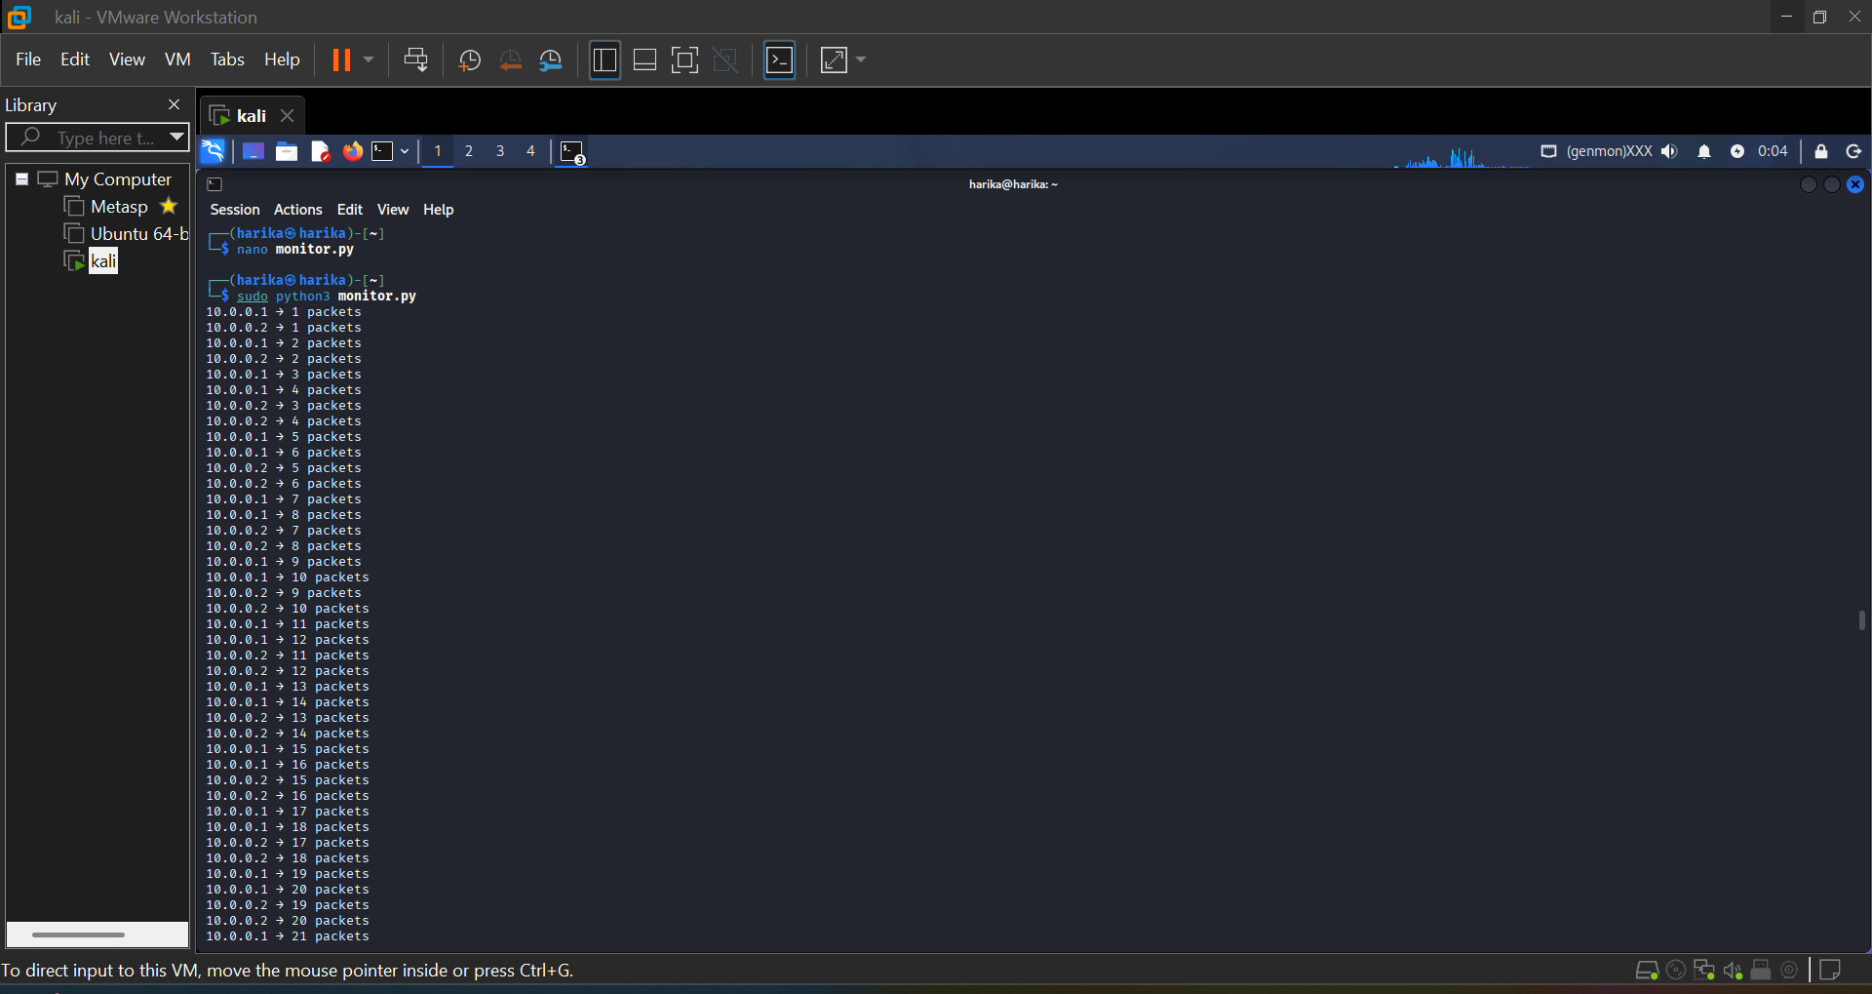

Step 8: Attack Detection Output
Alert generated when packet threshold exceeds
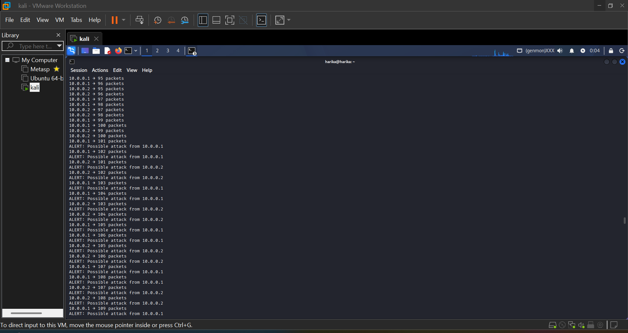

4. Result
The IDS successfully detected abnormal traffic and generated alerts.

5. Conclusion
The project demonstrates a working IDS using Scapy and Mininet for detecting DoS attacks.

